MILFORD ENERGY PLAN

Milford Energy Plan
(September 19, 2022)

The Milford Energy Plan was written by the Milford Energy Advisory Board (EAB) during the fiscal year 2021 and issued on (September 19, 2022) to provide guidance to the Mayor and Board of Aldermen, Milford, Connecticut.

Milford, a coastal community, is already facing the adverse impact of climate change, including more damaging storms and coastal flooding. The economic cost of severe weather events is passed down to municipalities, residents, and businesses. We must take an approach that both emphasizes resiliency while also reducing emissions to limit the costliest projections of the effect of climate change on Connecticut residences. The State of Connecticut has set Greenhouse Gas Reduction targets of 45% below 2001 levels by 2030 and 80% below 2001 levels by 2050. Connecticut has a goal to obtain 100% zero carbon electricity by 2030. The Milford Energy Plan lays out actions the City, residents, and businesses can take to help the state achieve this goal. While we cannot deny the urgency of the moment, it is important to note that while this plan may require some initial, up-front, costs, it can lead to long term savings and reduced long-term expenses. This plan outlines actionable long-term ways to save money through investments in energy-efficiency and renewable energy, all while making our city healthier, safer, and an even more attractive destination for people looking to raise a family, build a business, or even just to visit.

Energy Advisory Board Members (current)

J. Alan Brewster, Chair, former Deputy Dean, Yale School of Forestry and Environmental Studies
James Day, Solar Ambassador
John Karyczak, Home Energy Solutions Program Manager, United Illuminating
Curt Krushinsky, Architect, Fairfield University
Pieter Moen, Engineer, Intersystems

Energy Advisory Board Members (at time of initial drafting of Energy Plan

Melissa Meek, Program Manager, NMR Group Inc.
Sylvestre Moura, Milford Public Works Department
James Whitaker, Energy Manager, Milford Public Schools

Background

Initial Commitment

In September 2012, The City of Milford pledged to the State to reduce its energy use (within the Municipality) by 20 percent by 2018. With the endorsement of the City’s Board of Aldermen in June 2013, the Mayor, Benjamin Blake, appointed an Energy Advisory Board to provide advice and assistance to Milford in achieving this goal.

The EAB began by establishing a baseline year (FY 2010-11) and data on energy use by municipal building throughout Milford for that year and all subsequent years. The EAB took advantage of an offer by Sheri Borrelli at The Clean Energy Communities Program, a cooperative program run by United Illuminating (the City’s energy provider) and Energize Connecticut, to use the University of New Haven (UNH) to collect information on electricity, gas, and oil use by building throughout the period from 2010 to the current date. The process was carried out by four students at UNH (Jessica Zielinski, Vivek Shatto Antony, Simon Betancur, and Mohammed Albayati) under the direction of Amy Thompson, who started as an Assistant Professor of System &Industrial Engineering at UNH but during the process became President of Paguridae LLC. The UNH team used the US Environmental Protection Agency (EPA) Portfolio Manager system to enter the data use by building.

A final report was presented on April 28, 2015. The report showed that the School system had reduced its site energy use over the period FY 2010-11 through FY 2013-14 by 29.9 percent (normalized for weather changes) and the City’s municipal buildings over the same period had reduced their weather normalized site energy use by 6.0 percent. The net effect was that the City of Milford had already reduced its energy use by 22.3 percent as of FY 2014 and had already achieved its goal. The result was an annual savings in FY 2014 of over $578,000. On the school side, this savings was achieved largely by behavioral changes such as turning off lights and computers at night and lowering the thermostats on nights and weekends. After achieving these savings, the School Board approved the strengthening of each of the school’s roof and the installation of solar panels on each roof, which has achieved considerable additional savings.

The City achieved its annual FY 2014 savings primarily through upgrading the Parsons Building by adding new windows, new lighting, and the installation of an energy management system. At the same time, Milford also switched from oil to gas at City Hall and upgraded the entire building. Since FY 2014, the city has also installed solar panels on several buildings and in 2020 it installed a fuel cell at the Beaverbrook Wastewater Treatment Facility which also provides electricity to five other facilities/buildings in the City.

Solarize Program

In June 2014, Milford decided to send a proposal for the City to join the State’s Solarize program to provide solar panels to Milford homeowners at discounted pricing through participation in the program. The City designated the Energy Advisory Board to select the installer for the program and to administer the program throughout its duration (December 2014 through April 2015). The selected installer was Encon, which was selected because of their location in Stratford (no Milford installer bid on the program), marketing budget, and cost, among other factors. The official announcement of Milford’s selection and the installer was made in November 2014.

Following a letter from the Mayor and a flier sent to all households in Milford, the initial meeting to introduce the program and Encon was held in City Hall on December 3, 2014. It was well attended by about 250 people with the crowd expanding onto the balcony. All attendees were identified to be subsequently contacted by the vendor. By the end of the program, there were 400 expressions of interest, over 200 site visits, and more than 100 contracts presented. In the end 66 homeowners installed solar panels through the Solarize program. Installation took place over the summer and fall of 2015.

Although many households in Milford had chosen other installers and had already put solar panels on their roofs, it was clear by the summer of 2016 that there was still an interest in pursuing a Solarize option in the City. Since the State was continuing the program, Milford prepared another proposal to provide the option of discounted pricing to other homeowners. Once again, the Mayor designated the EAB to select the installer and to administer the program. By this time, Encon was no longer in the business of residential solar power and the EAB selected Ross Solar to be our installer.

The program officially began on May 11, 2017 and concluded on September 15, 2017. The results were substantially less than the first round of the program but by the end there were 180 expressions of interest and 110 site visits. 31 contracts were implemented for a total of 97 sets of installed panels due to the Solarize program. As of late 2018, a total of 869 solar installations had been made in Milford, so many people were going with other installers. As of today, the Milford EAB believes that over 1,700 homes have installed solar panels on their roofs.

Other Past EAB Activities

In July 2016 the US EPA’s Energy Star Program recognized the City of Milford for having 16 buildings qualifying for certification as Energy Star Buildings, including all 14 of the City’s schools as well as City Hall and the Parsons Center. This was the largest number of qualified municipal buildings in the State. This followed from the use of the EPA’s Portfolio Manager for tracking energy use in each building.

Subsequently, The Connecticut Conference of Municipalities and the Institute for Sustainable Energy at Eastern Connecticut State University launched the Sustainable CT program for municipalities throughout the State. This program established in 2018 has thirteen areas for municipalities to be evaluated on their actions to achieve sustainability. To receive Bronze Certification each town or city had to achieve an overall total of 200 points and at least one point in each of the categories. To achieve the highest level of certification, Silver Certification each municipality needed to achieve an overall total of 400 points.

The EAB sent two members to participate in Working Groups that helped define the nine areas for points. James Whitaker was a member of the Efficient Physical Infrastructure and Operations Working Group and Alan Brewster was a member of the Clean and Diverse Transportation Systems and Choices Working Group. When the final definitions and allowable points were established, Milford was awarded a Bronze Certification in the 2018 inaugural year with a total of 265 points, of which 60 points were realized for the work of the City on reducing its energy use. Milford continued to actively achieve sustainable goals and complete sustainable projects. In the fall of 2021, Milford was awarded Silver, the highest level of certification from Sustainable CT. The Energy Advisory Board helped show the city had a 20% electricity reduction in municipal and school buildings.

The EAB also contributed to the preparation of a proposal to the State of Connecticut for the establishment of a microgrid to protect the City from a loss of total power during a weather emergency; planned and implemented an Environment and Energy program at the Library and a program on Electric Vehicles; sought to participate in the energy planning for a new Police Station; and encouraged the use of a fuel cell to power a wastewater treatment facility.

Recommended Goals

Overall: Eliminate all net carbon emissions in Milford by 2050

Households:

In order to achieve our goal, we recommend the following goals for the residential sector:

- Increase energy efficiency
- Weatherize homes
- Increase use of solar panels for power
- Eliminate fossil fuel use in heating
- Eliminate fossil fuel use in cooking
- Reduce waste, especially compostable waste
- Shift to electric vehicles
- Involve residents in promoting the goal of 100% renewable energy by 2050

Interim Goals:

Encourage 50% of all households to adopt HES audits by 2030. As of 2020, 19% of all residential households in Milford have participated in the Home Energy Solutions (HES) program (Table 1), a program offered through Energize Connecticut that provides the average household with $1,000 in services and $200 to $250 savings annually on energy bills. For a small co-pay, customers access the core services and receive customized recommendations for additional energy-savings opportunities. To achieve our goal of 50%, we would need to increase the number of Milford homes participating in this program to 3% per year (from the current average of 1% per year). There is no cost to the city of Milford for residents to participate in this program.

Table 1: HES/HES-IE Audits in Milford as a Percent of Total Households
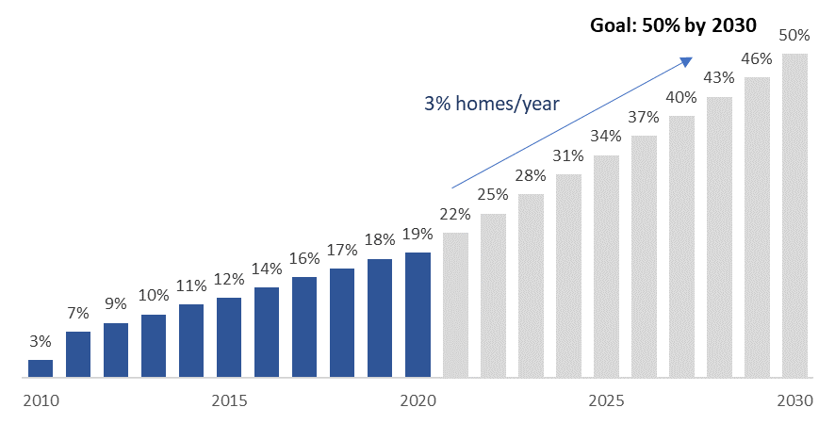

Encourage 25% of all households to install solar panels by 2030. As of 2020, approximately 8% of homes in Milford have solar panels. In 2016, we estimated that approximately 20% of homes in the city are suitable for solar and the other homes could have shared solar arrangements (particularly for multi-family units).

Reduce fossil fuel use in heating, cooling, and cooking by 50% by 2035. Much of this reduction can be achieved by switching to heat pumps [air or ground], which would greatly reduce energy use and move households from fossil fuels to electricity. In addition, switching cooking to all electric would also remove other toxic emissions in homes.

Shift 100% of purchases of new cars to EVs by 2040. California announced in September 2020 that all new cars and passenger trucks sold in California would be zero-emission vehicles by 2035. The rest of the country may not be far behind. While this goal would not cost the city anything, the city could encourage drivers to adopt electric vehicles by working with the state to install more charging stations.

Get 25% of all households to reduce waste by 2030. Approximately 25% of household waste is composting. By encouraging home composting, the city could reduce the cost of garbage collection and associated fees. Milford could go a step further and implement a city-wide curbside composting program.

Commercial and Industrial:

- Increase energy efficiency
- Increase use of Solar Panels for power
- Eliminate fossil fuel use for heating and cooling
- For restaurants and fast food establishments, eliminate fossil fuel use in cooking
- Reduce waste and compostable waste from restaurants
- Adopt use of Electric Vehicles, where possible
- Involve in promoting 100% renewable energy

Interim Goals:

Encourage 50% of Milford businesses to participate in energy savings programs by 2030. As of 2020, 24% of businesses in Milford have participated in at least one business energy-saving program offered by Energize CT (Table 2). To achieve our goal of 50% participation by 2030, we would need to encourage an additional 2-3% of businesses to participate per year, a 1-2% increase from part participation trends. There is no cost to the city of Milford for businesses to participate in this program.

Table 2: Business Energy Savings Program Participation as a Percent of Total Businesses
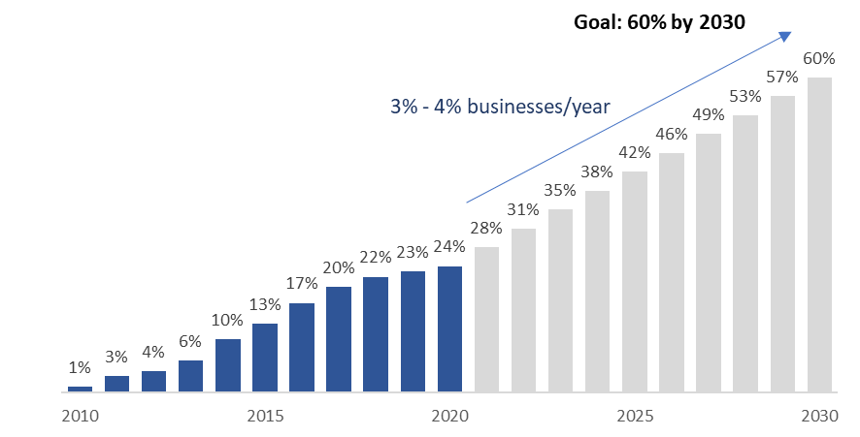
Goal: 50% by 2030
2% - 3% businesses/year
Reduce energy use by 25% by 2030 and 50% by 2040.

Install solar panels on flat roofs and/or parking lots of 25% of businesses by 2040. A 2016 study conducted by the Milford EAB identified at least 20% of flat roof and parking space at Milford businesses that could accommodate solar panels.

Get 25% of all businesses to reduce waste by 2030. Similar to the residential goal above, reducing compostable waste from businesses (with a particular focus on restaurants and food service establishments) will save the city money and divert organic waste from the landfill back into our food system.

Reduce fossil fuel use by 50% by 2040. By encouraging electrification in business sectors where it is feasible now, we can start this trend in Milford. New technologies are coming to market and electrification in more industries will be possible going forward.

Municipal Activities:

- Adopt goal of 100% net reduction of carbon emissions by 2050
- Track energy Usage through ENERGY STAR Portfolio Manager
- Increase energy efficiency
- Increase use of solar panels for power (utilizing flat roofs, parking lots, and open space)
- Reduce fossil fuel use for heating
- Reduce overall waste by switching to separate pickup of compostable waste
- Adopt electric vehicle fleets for local use, with installation of necessary charging stations
- Promote transit-oriented development
- Support the purchase of all-electric school buses
- Modify building codes to support all new construction to be 100% electric and energy efficient
- Modify building codes to encourage all renovation construction to be 100% electric and energy efficient
- Promote 100% renewable energy by 2050
- Support programs to remove carbon from the air (tree planting, etc.)
- Advocate for effective state policies

Interim Goals:

Promote installation of charging stations throughout Milford by 2030. According to Connecticut’s Electric Vehicle Roadmap, eliminating range anxiety is a key barrier to customer adoption of electric vehicles (EVs). The city of Milford can promote EV adoption by increasing the number of public charging stations throughout the city and at city buildings. We expect some public funding to become available to support this initiative.

Support the purchase of some electric buses for all Schools by 2030. Electric school buses can save nearly $2,000 a year in fuel costs and $4,400 a year in reduced maintenance costs. A 2014 analysis by the Chicago Transit Authority estimated that a single electric bus saved the city nearly $80,000 a year: $25,000 in fuel and $55,000 in avoided healthcare expenses resulting from cleaner air.

Purchase electric vehicles to replace the city fleet when a gas vehicle is retired from service, where possible. Electric vehicles are less expensive to maintain and have been shown to save money over the lifetime of the vehicle. We encourage city departments to consider purchasing electric vehicles when it is time to retire existing vehicles. Many electric vehicles now have ranges of over 250 miles on a single charge.

Make energy-efficiency improvements in all municipal buildings by 2035. The city has already made significant progress in several of its buildings. While there is some up front investment involved, energy efficiency improvements ultimately save taxpayer money and can even improve the comfort and health of people working inside the buildings.

Install solar panels on all suitable flat roofs and parking lots by 2035. Solar canopies provide shade for parked cars and electricity for nearby municipal buildings. The city should also utilize net metering and virtual net metering and implement the use of batteries for energy storage.

Eliminate 50% of fossil fuel use in buildings by 2035. The City of Milford can lead by example by electrifying city buildings where feasible, taking advantage of EnergizeCT programs and other funding sources to help finance the new equipment. In particular, buildings in which heating or hot water equipment is due for replacement should be identified as the first focus of this policy.

Modify Building Codes in 2025, 2035, and 2045.

Non-profit Organizations:

- Increase energy efficiency
- Weatherize buildings
- Increase use of solar panels for power
- Eliminate fossil fuel use for heating and cooling
- Reduce waste
- Involve the non-profits in promoting energy-efficiency 100% renewable energy in their communities

Interim Goals:

Increase energy efficiency by 50% by 2035. While we do not know how many non-profits have taken advantage of energy-efficiency programs, we propose conducting outreach to ask about their energy needs and connect them with EnergizeCT programs to help reduce energy use. These programs are no cost to the City of Milford.

Eliminate 50% of fossil fuel use by 2040. Encourage non-profits to consider energy-saving electric equipment, such as heat pumps, to replace equipment that is old or failing.

Transportation:

- Encourage rapid shift to Electric Vehicles (EVs) for private use (with incentives for the use of home charging stations)
- Establish networks of charging stations for EVs for both private cars and City fleets
- Promote bicycle and pedestrian use of all streets
- Promote electric buses for transit use
- Promote electric buses for School use
- Improve efficiency and inter-connectedness of all public transit
- Promote programs that reduce idling

Interim Goals:

Adopt targets for electric buses for transit use by 2030. As discussed above, electric buses save money and are better for the health of the community.

Establish network of charging stations for private EVs by 2035 and City fleets by 2030. These actions are in line with the state’s goals to increase EV adoption statewide. State funding and support may be available for these initiatives.

Complete implementation of “Complete Streets” initiative by 2030. Complete Streets means ensuring that all modes of transportation are considered in the planning and design of our transportation network.

A Blueprint for Success: Recommendations for Next Steps

The Milford Energy Advisory Board is looking forward to working with the city to successfully promote and implement the Milford Energy Plan.

Overall, we recommend taking these steps:

- Create a website that tracks the City of Milford’s progress toward the 2030 and 2050 goals
- Pledge at least 25% of annual savings from energy efficiency and renewable energy at city sites to a fund supporting the above goals for other sectors
- Reach out to community groups and agencies (e.g., churches, Chamber of Commerce, service organizations, environmental groups, neighborhood groups. etc.) to encourage the adoption of various steps to achieve 100% by 2050

Next, we outline some specific actions that the City of Milford can take to promote and encourage the goals and interim goals outlined below for citizens, community groups, and business owners in Milford:

Households:

- Promote a “Go Green Pledge” asking residents to commit to the goals above
- Promote Energy Efficiency audits
- Feature local contractors on the website who can do the energy-efficient upgrades (as a starting point, reach out to contractors on the Energize CT website)
- Feature testimonials from residents about the energy/money savings
- Promote tax incentives for energy-efficient new construction
- Encourage energy-efficiency upgrades & weatherization when residents get home renovations and additions
- Education campaigns & take-home materials distributed at school
- Incentivize landlords to make improvements
- Work with local realtors to help them promote Milford’s clean energy goals and promote individual homes that have undergone energy-efficient upgrades. Create a welcome packet with information about Milford’s Energy Plan, our successes, and how to participate.

Commercial and Industrial:

- Promote a “Go Green Pledge” asking businesses to commit to the goals above
- Promote Energy Efficiency programs for Commercial clients
- Promote C-PACE (Commercial – Property Assessed Clean Energy) Program
- Promote other Green Bank financial programs for commercial clients
- Feature local contractors on the website who can do the energy-efficient upgrades (as a starting point, reach out to contractors on the Energize CT website)
- Feature testimonials from business owners about the energy/money savings
- Tax incentives for energy-efficient new construction

Municipal Activities:

- The Milford Energy Advisory Board proposes to meet with the Mayor, Board of Alderman, Department Heads, and the School Board to discuss the proposed Energy Plan, solicit suggestions, and listen to concerns.
- Promote overall goal of 100% reduction of Carbon Emissions by 2050
- Promote purchase of electric vehicles for use in all settings where appropriate
- Promote installation of electric charging stations (both public and private)
- Incorporation of the Energy Plan in Milford’s Plan of Conservation and Development (POCD)
- Milford EAB review of the POCD for meeting goal of 100% by 2050
- Work with the city and schools to promote activities and programs that align with the Energy Plan
- Review Building Code processes for improvement
- Complete implementation of “Complete Streets” efforts
- Seek grant funding for various energy reduction programs
- Encourage devotion of 25% of annual municipal savings from energy reductions to other energy programs
- Support state passage of legislation to allow for Community Choice Aggregation
- Support other state-level legislation allowing for energy reduction programs

Non-profit Organizations:

- Meet with Non-profit groups
- Promote a “Go Green Pledge” asking non-profits to lobby the State about such goals
- Promote Energy Efficiency Programs for non-profits
- Promote Green Bank financial programs for non-profits
- Feature testimonials from non-profit leaders about energy/money savings

Transportation:

- Improve efficiency and interconnectedness of Public Transit
- Adopt the use of electric buses for transit use
- Adopt the use of electric buses for school use
- Promote reduced idling programs
- Support statewide initiatives for improved transportation systems

For example, the referenced report estimates that it will cost Milford, CT $297.3 million by 2040 to protect against sea-level rise under moderate projections: https://www.climatecosts2040.org/files/state/CT.pdf
Energize CT. “Home Energy Solutions – Core Services.” Accessed April 4, 2021. https://www.energizect.com/your-home/solutions-list/home-energy-solutions-core-services#:~:text=The%20average%20home%20in%20Connecticut,on%20their%20annual%20energy%20bills.
As of April 1, 2021, the co-pay is $50; co-pay is waived for income-eligible customers.
Energize CT currently offers rebates for Connecticut customers looking to install heat pumps for heating, air conditioning, and water heating.
Sabrina Imbler. “Kill Your Gas Stove.” October 15, 2020. The Atlantic. https://www.theatlantic.com/science/archive/2020/10/gas-stoves-are-bad-you-and-environment/616700/
https://www.gov.ca.gov/2020/09/23/governor-newsom-announces-california-will-phase-out-gasoline-powered-cars-drastically-reduce-demand-for-fossil-fuel-in-californias-fight-against-climate-change/
Resources for community composting and pilot programs in Connecticut: https://portal.ct.gov/DEEP/Waste-Management-and-Disposal/Organics-Recycling/Composting-and-Organics-Recycling
For example, hybrid technologies that allow companies to shift fuel usage based on market factors: https://www.nsenergybusiness.com/features/industrial-electrification-mckinsey/
https://portal.ct.gov/-/media/DEEP/air/mobile/EVConnecticut/2020-04-22---EV-Roadmap-for-Connecticut---FINAL.pdf
US PIRG. “Paying for Electric Buses.” Fall 2018. https://uspirg.org/sites/pirg/files/reports/National%20-%20Paying%20for%20Electric%20Buses.pdf.
Veronica Penney. January 15, 2021. “Electric Cars are Better for the Planet – and Often Your Budget, Too.” The New York Times. https://www.nytimes.com/interactive/2021/01/15/climate/electric-car-cost.html.
https://portal.ct.gov/DOT/PP_Policy/Documents/Complete%20Streets

